FOUNDATION FOR VIRTUAL AND AUGMENTED REALITY SYSTEMS
Lecture35
Lec-35: Usability requirement gathering and specification
Hello and welcome to the NPTEL MOOCs course on Foundation for Virtual and Augmented Reality Systems. In this lecture, we are going to start discussion on a new topic, that is Requirement Gathering. Now, previously we talked about extended reality systems as examples of interactive systems, and the main concern in interactive system development is the taking care of the concern of usability. Now, in this lecture, what we are going to do is we shall learn about the methods for gathering end user requirements so that usability is ensured.
So, what are the processes that we can follow to gather end user requirements which will lead to a usable design that we are going to learn in this lecture? Now, we shall first go through the general idea about user requirement gathering and also specification. Specification is required for system implementation. So, we will learn in general what are the techniques used to gather the requirements and also specify them. Then we shall link our discussion, our theoretical knowledge,
with respect to the case study that we have introduced earlier, that is we shall talk about the specific case of Majuli VR Tour requirement gathering and specification. So, let us first learn about usability requirements, what it means. Now, when we talk of requirement gathering, so let us quickly recollect the interactive system development life cycle as we have learned about it in the previous lecture. So, this is the life cycle; it comprises a feasibility study, requirement gathering, analysis and specification, then a design prototype evaluation cycle, code design, actual coding, then code testing, then an empirical study or usability testing, and finally deployment.
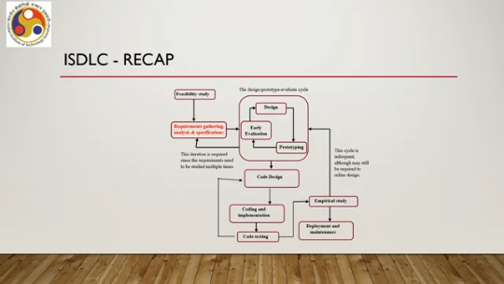
So, we are going to learn about this stage, requirement gathering stage. With respect to end user requirements, not the client requirements. Now, we introduce the term system user-centered design. So, there are two things. One is system-centered design; the other one is user-centered or user-centric or human-centric design.
One is SCD; the other one we can refer to as UCD. So, what is the difference between the two? Let us try to understand with respect to some interesting comic strips. Consider these two characters.
They are conversing. One is the software developer; the other one is the manager. This is a Dilbert strip. Some of you may have been reading it regularly. So the developer talks about
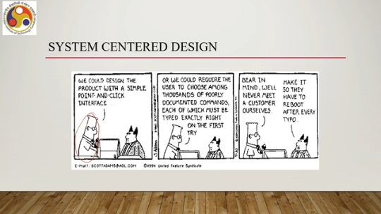
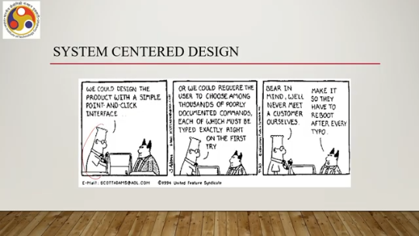
how to better develop the system: we could design the product with a simple point-and-click interface so that users find it easy to operate. So, the developer is talking about all the possible options, or we could require the user to choose among thousands of poorly documented commands, each of which must be typed exactly right on the first try; otherwise, the system will crash or hang. So interestingly, the developer discusses all possible design options or development options with the manager.
In continuation of those earlier options, the developer also talks about, bear in mind, we will never meet a customer ourselves because they are the developers, customers are hidden from them. And the manager advises that make it so they have to reboot after every typo. Now, this sequence of events, although if a system is designed in such a bad way, intuitively we feel that it is a very bad system. However, that is not necessarily the case always. When we are talking of system-centered design, that is, we are only bothered about the system rather than the user of the system, then probably this type of approach makes sense.
So, the main concerns for system-centered designers: what can I easily build on this platform? I means the developer or the manager. What can I create from the available tools? Again, I is the developer. What do I as a programmer find interesting?
So, here I refers to the developer. So, essentially, the development is driven by the skill and interest of the developer rather than the needs and expectations of the user. So, that is the system-centered design. On the other hand, we are concerned here about user-centered design.
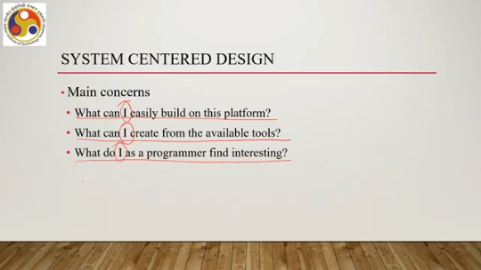
In such a case, the design is based on a user's abilities, context, goals, needs, expectations, and such things. So, the concern here is not the programmer's convenience; it is about the user's abilities, user's goals, user's needs. So, the viewpoint changes. So, in system-centered design, the entire thing is driven by the developer's point of view, whereas in user-centered design, ideally everything should be driven by the users, from the user's point of view.
Let us try to understand these in terms of one example. So, in the previous lecture, we introduced the calendar application, a mobile application. Now, when we talk of requirement gathering for the calendar application, when we know that the calendar application has to be developed following a user-centered approach, design approach. So, we have to gather the requirements. What are the requirements?
If we are asked to gather the end user requirements, what potentially can be such requirements? If we say we need to develop it for the mobile platform, is it part of the requirement? If we say what programming language we are going to use, say for example Java or JavaScript, is it a requirement? If we say How are we going to store the various information needed, such as reminders and special events?
Should we use some RDBMS tools such as MySQL? Is it a requirement? Are these basically end user requirements which ensure usability? There may be many more such questions which may come to come to the developer's mind regarding the requirements.
But these are not requirements as such. In fact, here the term requirement specifically refers to end user requirements. So, these are not essentially end user requirements as such. Now, some of these requirements are related to feasibility. the first stage, such as we need to develop it for mobile platforms, what programming languages are we going to use.
These are requirements related to feasibility. Some may be related to the design stage. Remember that we have utilized the notion of design prototype evaluate cycle. So, some may be related to the design state of the interface or design stage of the code. Now, here.
When we have questions like, how are we going to store the various information needed, such as reminders or special events, should we use some RDBMS tools such as MySQL? These are part of the code design stage, not the interface design. So, the questions that may come to our mind are: They are not necessarily requirements, but they are part of other stages. So, our objective is to identify requirements that ensure usability and lead to system specification.
So, both are important. One is we have to identify requirements that ensure usability, but Also, we need to be able to specify those requirements so that they can be converted to plans for implementing the system and deploying the system. So, system specification is also important for design and implementation of the system. So, what do we need?
Gathering of usability requirements and analysis and specification of the requirements to be able to convert those to system design and subsequently implementation. Now, when we talk of usability requirements or gathering of usability requirements, such requirements are generally treated as a type of non-functional requirements. So, those of you who have done a course on software engineering, you know that. There are two types of requirements: functional and non-functional.
Here, we are dealing with non-functional requirements. Usability requirements are essentially part of non-functional requirements. Now, let us quickly have some idea about this non-functional requirement. So, these are system characteristics that cannot be expressed as functions. So, when we talk about functional requirements, essentially we are referring to
system features and abilities of the system to carry out tasks in terms of some functions which are treated as black boxes. So, we provide some input and the function generates some output once it is implemented. Those are functional requirements. As opposed to that, when we are talking about usability requirements, these are system characteristics along with many other such characteristics which cannot be expressed in terms of functions.
They are typically related to quality attributes of the software. Now, there are several categories of such non-functional requirements, such as performance-related non-functional requirements, operating constraints as non-functional requirements, economic considerations. lifecycle requirements, as well as interface issues. Now, our interest lies in this last category: interface issues.
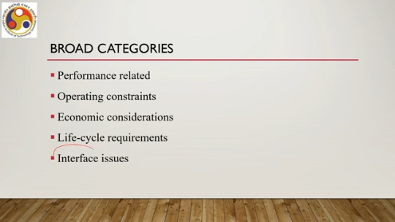
So, when we talk of interface issues, essentially it refers to the design of the interface or the qualities of the interface that should be usable, that should make the interface usable. Now, in fact, there are two issues. One is how the system is to interface with its environment, users, and other systems. All these concerns are taken care of under the interface issues. Now, it has an external system interface; that means hardware and software interfacing,
interfacing between the hardware and software, as well as the user interface where usability issues come into the picture. Now usability is our focus. So, external system interface we are not going to talk about much in this course. Now, when we talk of usability, we have to remember that we are dealing with interactive systems meant to be used by non-experts or those who are not aware of how the system works. So, in that context usability is very important.
Now with that knowledge, let us now try to understand the requirement gathering methods that we can deploy to gather requirements and also ensure usability. So when we are talking of gathering end user requirements, our motto should be know the user. In other words, know the user, who are the users of your system. So, that should be our very first step unless we are able to categorize the users unless we are able to specify the users we will not be able to gather end user requirements. Now, in this context let us quickly recap the usability definition which we have encountered earlier.
The ISO definition of usability, which we have encountered earlier, is the extent to which A product can be used by specified users to achieve specified goals with effectiveness, efficiency, and satisfaction in a specified context of use. So, it talks about a usable product with respect to a specified group of users trying to achieve specified goals in a specified context of use. with effectiveness, efficiency, and satisfaction. So, essentially, any usable product must have a specified context of use.
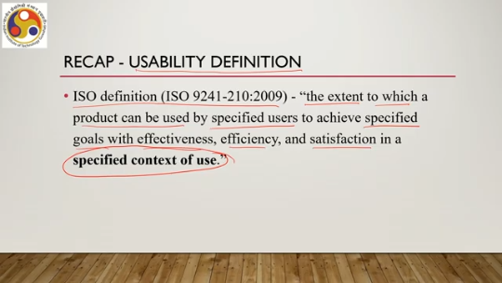
Now, based on that idea, we can talk about one requirement gathering method, an end user requirement gathering method that is called contextual inquiry. Note that there can be many requirement gathering methods. One is contextual inquiry, which is a method to gather end user requirements which in our context is the same as usability requirements, and one of many such methods. So, do not assume that this is the only method possible; there are many such methods.
However, we will be going through this method in a little more detailed manner. So, as to understand how the usability requirements are gathered and subsequently how those are used, analyzed, and used. Now, the contextual inquiry method is an old method. Its importance in user-centered design was highlighted way back in 1988, although the term used at that time was phenomenological research method. And by the end of the 1990s, it became well developed and popular.
So, it is more than 30 years old. Now, this method is often referred to as a semi-structured interview process, which consists of both interviews and observations. Now, what is the primary objective of this method of contextual inquiry? The primary objective is to watch and observe users perform tasks in their natural work setting or, in other words, the work context. So, when you say usability is the quality when it is measured against a specified context of use, in other words, the work context.
So, contextual inquiry essentially tries to gather end user requirements when the users are working in a specified context, which we can call a natural work setting. Now, during observations, when we are following the contextual inquiry method, the users may be asked questions to clarify certain behaviors or activities. So, this is the part of the interview. That is asking for clarification. However, the primary objective is to observe and to gather more insight about user behavior.
The method also provides for interacting with the users for clarification. Generally, it takes one to two hours if everything is well planned. Now, the observations including interaction with the users are supposed to enable the designers to learn about the task domain, work culture and physical and social constraints at the workplace based on which design decisions can be made. So, the knowledge is important since the specific work context is an essential part of the definition of usability.
So, since usability is defined in a specific work context, it is essential to know how the users behave in that specific work context to ensure that the software or the product or the system that we are building is usable. Let us try to understand the importance of this method, From the point of view of system development. For example, let us recollect the calendar app that we have already talked about.
Let us assume that the target group of users for the app are the managerial staff of any organization. Remember that we have to start by first identifying the group, the user group. So, in this case, let us assume that the user group comprises the managerial staff of a given organization. Now, without any knowledge about how the managerial staff behave in general when they are in their work setting, we can come up with all sorts of possible designs.
So, we do not know what the unique behavioral traits of the managerial staff are unless we study them. And unless we study them, unless we gather the knowledge, we will not be able to refine the design. We will only be coming up with all sorts of design possibilities, although some of those or the majority of those may not be valid in the given work context. However, let us assume that we have performed a contextual inquiry and in the inquiry method, we observed Two important activities performed by the users, that is the managerial staff.
Set meeting dates and reminders. Now, with this knowledge, we can be certain that these features must be included in the design. Otherwise, the system will not be usable for the given user group. So clearly, a calendar app intended to be used by this group of users must have support for these activities. Now if we had not done the contextual inquiry this knowledge would not have come to us and
we probably would have come up with some design having all sorts of features where these two are more important but are given equal importance with other unnecessary features. So in that case, the usability would have been compromised. So, that is the importance of contextual inquiry. So, let us summarize what we have learned so far.
We started talking about usability requirement gathering. That is a very essential part of ensuring a usable design; unless we gather the usability requirements, we will not be able to come up with a proper design that takes care of users' needs and expectations. Now, there are different methods to do that. So, we are talking about one method: contextual inquiry.
We started with the basic idea of the method. In the next part of the lecture, we are going to continue on this method of requirement gathering. So, I hope you are able to follow whatever we have covered. So, we will continue in the next part of the lecture. Looking forward to meeting you all again.
So, thank you, goodbye, and happy learning.

